2026 Glasstech Mexico Sponsorship order form (Below price is for exhibitors only)
Company Name: |  |  | Booth No.
Item | Quantity | Unite Price -CAD | Sub-Total-CAD
Catalogue Front cover  (140X150mm) | 1 | 2800
Catalogue Back cover  (140X210mm) | 1 | 2100
Catalog inside page  (140X210mm) | 1 | 700
Show site hall banner (logo)  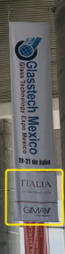 | 1 | 700
Sponsor for badges  exclusive  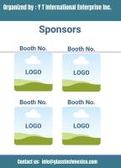 | 1 | 2100 | Taken
Sponsor for Handbags  exclusive | 1 | 1400
Sponsor for Badge Lanyard  exclusive  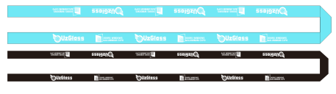 | 1 | 2100
Sponsor for Conference  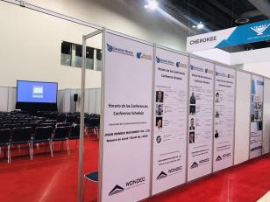  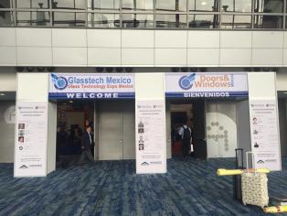 | 1 | 700/logo
General sponsors  logo on website and show site as sponsors | 1 | 700
Sponsorship at Visitor registration system (logo)-Digital for 3 months.  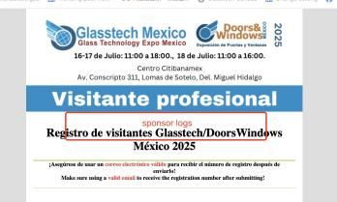 | Multi | 700/logo
Sponsorship at Email Blast  a banner at Email content-Digital for every 2 times.  Bannar size: 150X1000px | Multi | 700/banner
Sponsorship at Venue main entrance (logo)  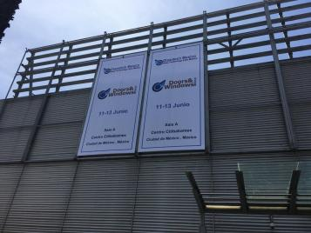 | Multi | 850/logo
Total (CAD)

